import matplotlib.pyplot as plt

import numpy as np

x = np.arange(-1,2, 0.1)

y = x**3+1.5*x-1# plotting the points

y2 = x

plt.xlabel('x - axis')

plt.ylabel('y - axis')

plt.title('intersection of g(x) with y=x')

ax = plt.gca()

ax.axhline(y=0, color='k')

ax.axvline(x=0, color='k')

plt.plot(x, y)

plt.plot(x, y2,color='green')

plt.show()

inter=[0,2]

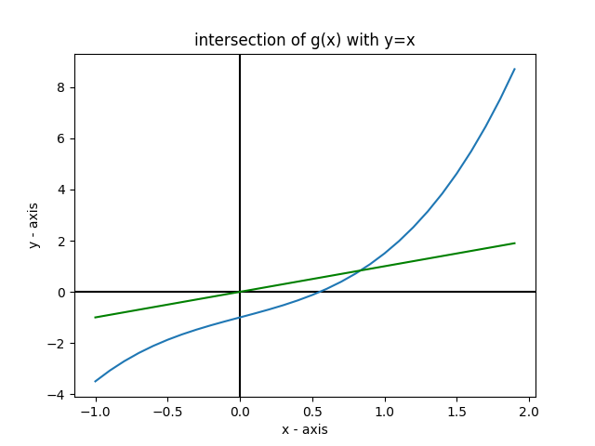

import math

df_a=3*0+0.5

df_b=3*4+0.5

M=math.ceil(abs(max(df_a,df_b)))

print(M)

l=[1]

p0=1

for i in range(30):

    l.append(p0-(p0**3+0.5*p0-1)/M)

    p0=p0-(p0**3+0.5*p0-1)/M

E=[]

R=[]

for i in l:

    E.append(abs(l[-1]-i))

    R.append(E[-1]/i)

print(f'{l} - p1,p2,p3,p4,p5')

print(f'{E} - error')

print(f'R - relative error')

a=0

b=1

l=[]

for i in range(15):

    c=(a+b)/2

    # print(a,c,b)

    print(a,b,c)

    if abs(c**3+0.5*c-1)<0.0001: break

    l.append(c**3+0.5*c-1)

    if c**3+0.5*c-1>0: b=c

    elif c**3+0.5*c-1<0: a=c

print(l)

import matplotlib.pyplot as plt

import numpy as np

x = np.arange(-2,2, 0.1)

y = x**3+0.5*x-1# plotting the points

plt.plot(x, y)

ax = plt.gca()

ax.axhline(y=0, color='k')

ax.axvline(x=0, color='k')

plt.show()

